**MegaDesk Assignment**

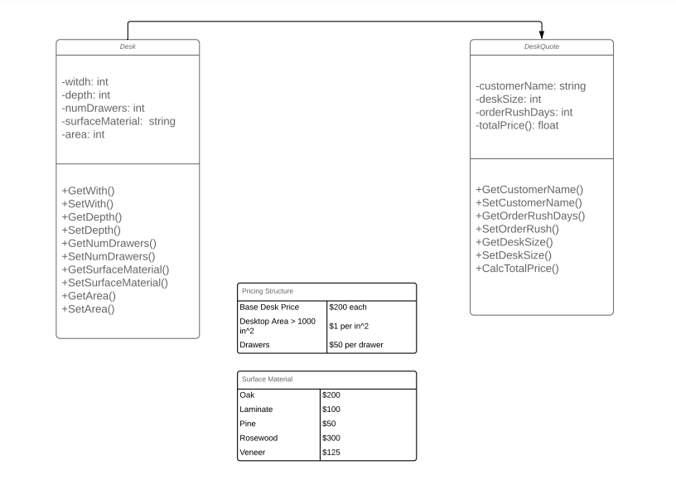

**Pseudocode**

**Desk:**

Int width;

Int depth;

Int numDrawers;

int surfaceMaterial;

**DeskQuote:**

String customerName;

Int deskSize;

Int orderRushDays ;

totalPrice;

string surfaceMaterial[] = {

oak = $200,

laminate = $100,

pine = $50,

rosewood = $300,

veneer = $125;

}

Int baseDeskPrice = $200;

If desktopSurfaceArea > 1000 in^2 == $1 * in^2;

Int drawers = $50;

CalcAreaDesk:

Width => 24 in && width <= 96 in;

Depth => 12 in && Depth <= 48 in;

Area desk = with * depth

CalcRushOrderPrice:

For 7 days order

If desktop surface area is => 2000

Rush order price = $40;

Else If desktop surface area > 1000 && desktop surface are < 2000

Rush order price = $35;

Else

Rush order price = $30;

For 5 days order

If desktop surface area is => 2000

Rush order price = $60;

Else If desktop surface area > 1000 && desktop surface are < 2000

Rush order price = $50;

Else

Rush order price = $40;

For 3 days order

If desktop surface area is => 2000

Rush order price = $80;

Else If desktop surface area > 1000 && desktop surface are < 2000

Rush order price = $75;

Else

Rush order price = $60;

CalcTotalPrice –

Int desktopSurfaceAre;

If desktop surface are > 1000 sqr in

Total price = $200 + (numDrawers * $50) + surface material price + rush order price + (desktopsurfaceArea + $1)

else

Total Price = equals 200 + number of drawers * 50 + surface price + rush order price